Curriculum vitae

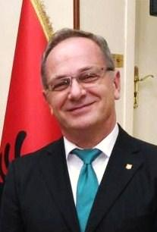

**Rezar Bregu**

Ambassador Rezar Bregu was born in Tirana in 1961. He completed his high school education in Tirana at the Ismail Qemali High School and higher education studies at the Agricultural University of Tirana in Agronomy, where he graduated in 1984 with very high grades.

He completed his postgraduate studies in Plant Breeding at IAMZ Saragossa and La Coruna, Spain. He holds the Master of Science degree in this field.

He has attended several qualification courses for international relations and Hispanic relations at the Diplomatic School Madrid - MFA Spain and MFA - Cairo, Egypt.

For several years, Bregu worked as a researcher at scientific centers, and in 1995, he entered the diplomatic career at the Ministry for Europe and Foreign Affairs of Albania. He worked at the Latin American Sector in the Directorate of the Americas and went on to become Head of the Middle East Sector in the Directorate of Asia and Africa. He later continued as Director of Asia, Middle East & Africa and Director of the Americas at the Ministry for Europe and Foreign Affairs in Tirana.

Abroad he served as First Secretary at the Albanian Embassy in Madrid, Counselor at the Embassy of Albania in Buenos Aires, Minister Plenipotentiary in Madrid, Ambassador of Albania in Buenos Aires, resident and non-resident in Chile, Peru, Colombia & Uruguay. From October 2018, he is Ambassador Extraordinary and Plenipotentiary of Albania in Brazil, resident.

Ambassador Bregu is author of scientific and Hispanics publications. He speaks Spanish, French, English, Italian and has basic knowledge in Portuguese.

He enjoys sports and art.

He is married to Mrs. Ledina Bregu and they have two sons, Enkel and Idlir.